**K4 CSF3133 REKA BENTUK ANTARA MUKA BERASASKAN WEB**

**SEM 3**

**LAB REPORT 2**

PREPARED FOR:

**ASSOC. PROF. TS. DR. WAN NURAL JWAHIR**

LAB ASSISTANT:

**MRS WAN FATIN FATIHAH**

PREPARED BY:

**NUR ADLYNN SYAKIRAH BINTI NOR KHAIRUL ANUAR**

NO. MATRIC:

**S76245**

SUBMIT BY:

**29 OCTOBER 2025**

**Activity 2.4 Creating Form**

**Activity 2.4.1 Basic Form Elements**

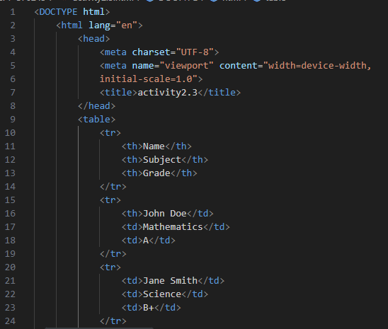

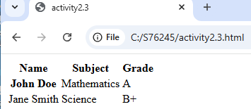

**Activity 2.3.2 Other Form Elements**

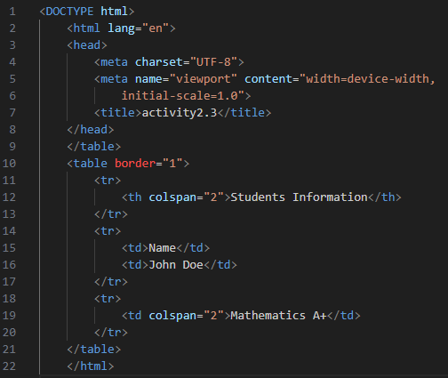

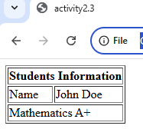

**Activity 2.4**

**Activity2.4.1**

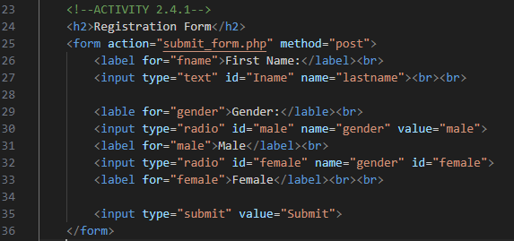

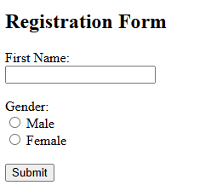

Activity 2.4.2

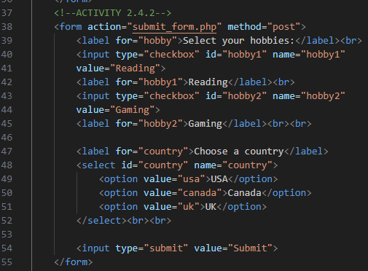

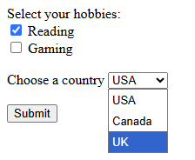

**Activity 2.5 Semantic HTML**

**Activity 2.5.1**

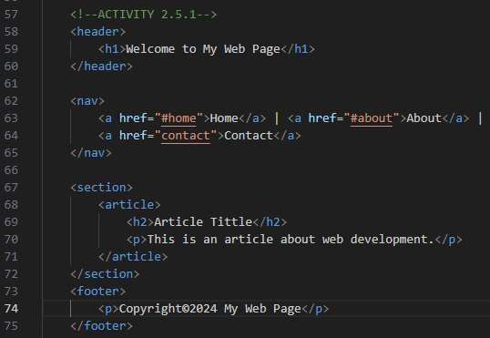

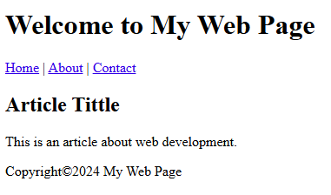

**LAB EXERCISE 2**

